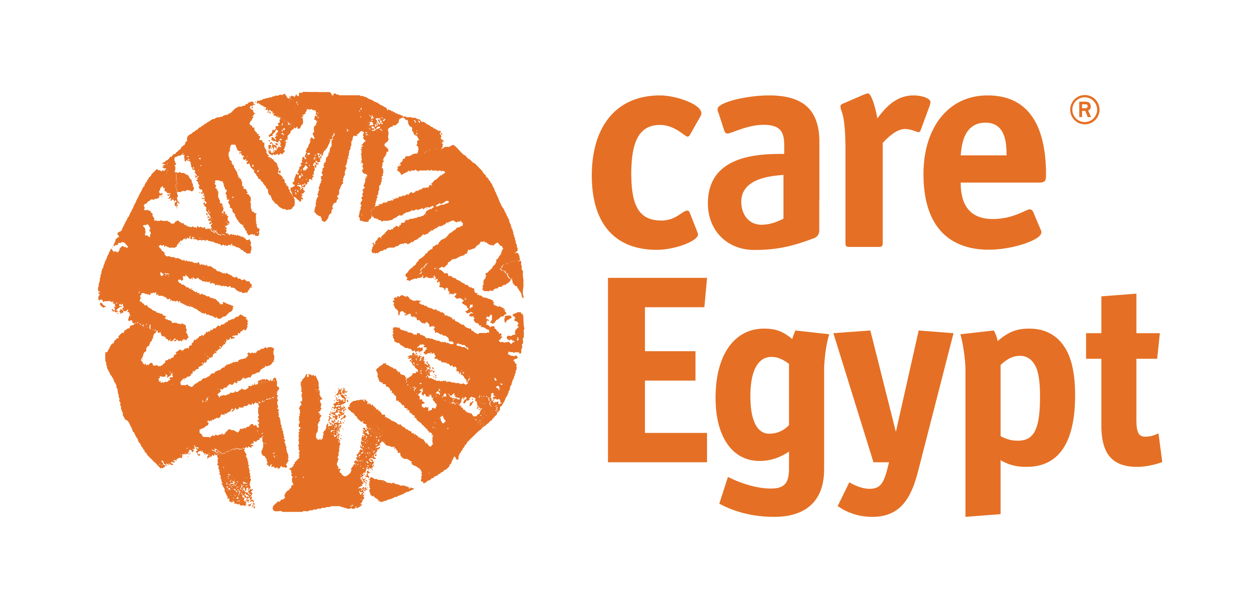

**Terms of Reference**

**Women Rights Program**

**UNFPA Funded Project**

**16 Days of Activism Against Gender-Based Violence Digital Campaign**

**Aug 2023**

**CARE Egypt Foundation (CEF):**

Care Egypt Foundation for Development is a civil institution registered in the Central Administration of Associations at the Ministry of Social Solidarity with the number “833 for the year 2018” and its address is 25 Asmaa Fahmy Street - Fifth Floor ( Plot No. 1 - Square Y ) [Qesm 1st Nasser City, Cairo, Egypt](https://eur01.safelinks.protection.outlook.com/?url=https%253A%252F%252Fwww.bing.com%252Fmaps%253F%2526ty%253D18%2526q%253DQesm%2525201st%252520Nasser%252520City%25252C%252520Cairo%25252C%252520Egypt%2526satid%253Did.sid%25253A432a45b5-5eab-ba46-5650-53b220c63f51%2526vdpid%253D7263824013959364620%2526mb%253D30.086544~31.313341~29.978529~31.435341%2526ppois%253D30.032536506652832_31.374341011047363_Qesm%2525201st%252520Nasser%252520City%25252C%252520Cairo%25252C%252520Egypt_~%2526cp%253D30.032537~31.374341%2526v%253D2%2526sV%253D1%2526FORM%253DMIRE%2526qpvt%253D%2525D9%252582%2525D8%2525B3%2525D9%252585%252B%2525D8%2525A3%2525D9%252588%2525D9%252584%252B%2525D9%252585%2525D8%2525AF%2525D9%25258A%2525D9%252586%2525D8%2525A9%252B%2525D9%252586%2525D8%2525B5%2525D8%2525B1%2525D8%2525A7%2525D9%252584%2525D9%252582%2525D8%2525A7%2525D9%252587%2525D8%2525B1%2525D8%2525A9&data=04%257C01%257CRana.Dimitri%2540care.org%257C1943b043a2d44a1e9d4708d9c2dcbe84%257Ce83233b748134ff5893ff60f400bfcba%257C0%257C0%257C637755075674438593%257CUnknown%257CTWFpbGZsb3d8eyJWIjoiMC4wLjAwMDAiLCJQIjoiV2luMzIiLCJBTiI6Ik1haWwiLCJXVCI6Mn0%253D%257C3000&sdata=zrh%252BE7gyx22FaGUakIvJ32SEvhs579zk2n7huFbhjto%253D&reserved=0), and that the institution is subject to the provisions of the law regulating the practice of civil work No. 149 of 2019.

CARE Egypt Foundation for Development is building on the legacy and expertise of CARE International in Egypt since 1954, by designing, implementing and managing development programs and projects aimed at helping the neediest communities in Egypt, by building strategic partnerships with the government sector, the private sector and the private sector, to help in Meeting the basic needs and improving the quality and standard of life in a sustainable manner and consistent with the culture, reality and the local and national context.

The Foundation focuses its interventions and designs its programs in the areas of economic and social empowerment of Egyptian women, developing and improving the educational environment, supporting the agricultural sector, especially small farmers, improving government performance and supporting confidence-building processes among development partners through the application of tools and methodologies for governance and social accountability, through investing energies and ideas And adopt initiatives that are in line with the development and improvement of the economic and living conditions of these communities to deal with addressing the root causes of poverty.

The Foundation is also committed to strengthening the role of the local civil society by including it as a partner in all the Foundation's projects in a manner that ensures building its capabilities and enabling it to play the developmental role required in the government's sectoral and geographical development plans and programs.

The Foundation works on extracting the most important international experiences in all areas of development, and presenting them in the local and national contexts, in addition to working to shed light and disseminate local experiences at the global level, in order to benefit from global experiences and present Egyptian development models to interested and actors at the global level.

**Women’s Rights Program**

The Women’s Rights (WR) Program is designed to empower poor and marginalized women in Egypt who suffer from rights’ violation. Its impact goal is: By 2025, poor women in Egypt especially in Upper Egypt are empowered and enjoying a better quality of life, having attained their rights. In order to achieve this goal, the program works with both the duty bearers in government and civil society, as well as rights bearers, women themselves, to address discriminatory attitudes and behavior towards women and girls.

The WR program works with the duty bearers to support their role to protect and uphold the rights of women, and also with the women to encourage them to understand voice and demand their rightful entitlements. The program works on three domains (agency, relations and structure) in order to empower poor women in Egypt to gain their rights. Through the focus on agency, women’s self-esteem and confidence are built, and women have increased financial independence to fulfill their potential as productive and income-earning members of their households and society. In addition, when power relations (families) are gender sensitive whilst tackling all forms of gender-based violence (GBV) within and outside the household, and when structures (social norms or laws) particularly in the area of personal status, domestic violence are reformed, passed and implemented, gender equality can be achieved.

The program has three themes, which are:

1. Tackling Gender-based Violence (GBV).

2. Women’s Social and Economic Empowerment.

3. Engaging Men and Boys (EMB).

**UNFPA Project: Comprehensive Approach to Eliminate Harmful Practices in Upper Egypt**

The Women’s Rights Program is designed to empower poor and marginalized women in Egypt who suffer from rights’ violation. Its impact goal is: By 2025, poor women in Egypt especially in Upper Egypt are empowered and enjoying a better quality of life, having attained their rights. In order to achieve this goal, the program works with both the duty bearers in government and civil society, as well as rights bearers, women themselves, to address discriminatory attitudes and behavior towards women and girls.

One of the main issues women face as gender-based violence is domestic violence, however, harmful practices still widely prevail within the society’s traditions. Female Genital Mutilation (FGM) and early marriage practices/crimes.

CARE Egypt has been selected by UNFPA to implement a project addressing Gender Based Violence against women in Upper Egypt . This project works towards ending FGM and early marriage, and supporting survivors who experienced any types of violence, exploitation, or abuse in the areas of Assiut, Sohag, Menya and Beni Suef.

The project will contribute to the long-term impact of ''women and girls in target communities fully enjoy their lives free of the risk of FGM and early marriage’’**.** It seeks to address the root causes of FGM and early marriage, develop a set of interventions targeting various stakeholders. These interventions aim to raise community awareness on reproductive health and girls’ education, actively engage men and boys in the discussion against early marriage, equip a cadre of local volunteers with the knowledge and skills needed to actively participate in the efforts to reduce the prevalence of harm practices and finally, networking all efforts in organized advocacy campaigns capable to achieve more gains that give women and girls a safe environment free from harmful practices in the targeted governorates.

**Objective of the Assignment:**

The purpose of this terms of reference is to hire a digital marketing agency with strong experience in social impact campaigns to support the project’s 16 Days of Activism Against Gender-Based Violence campaign through illustration, graphic design, media buying and social media moderation.

**Scope of Work and Deliverables:**

The agency is expected to:

1. Create 8-10 visuals including custom illustration and design.
2. Send us options for different illustrator portfolios for us to choose from or accept our recommendations to outsource.
3. Accept any comments and feedback from the communication team and project manager regarding the final version of posts.
4. Media buying for 10 posts across Facebook and Instagram. (Budget for Ad spending will be given) with target audience across the country, especially in Upper Egypt and a wide demographic, men and women or different age sectors.
5. Engagement on each post to reach minimum
6. Moderate social media comments/messages on the campaign for 4 hours per day across the 16 days of the campaign.

**Deliverables:**

* 8-10 visual posts.
* Media buying for 8-10 posts.
* Report for media buying outcome.
* Report for moderation outcome.

**Coordination and Reporting:**

The agency will report on progress to the communication team and project manager.

**Consultant’s Qualifications and Skills:**

* Strong experience in custom illustration and graphic design.
* Strong experience in media buying for a social impact campaign.
* Strong experience in social media moderation for a social impact campaign.
* Background in developmental work and familiarity with the target audience.
* The consultant should be a registered company/agency.
* Registered in الفتورة الاكترونية

**Conditions of Implementation:**

Interested applicants should submit the following documents in their offers;

Financial Proposal: The financial proposal should include a breakdown of the cost elements to assist in determining the rationale of the given rates.

CARE Egypt will withhold applicable taxes and deposit the funds with the applicable for tax authorities under this agreement

Consultant Professional Service Fees- may be subject to taxation

Consultant Administrative Costs – may not be subject to taxation

**The deadline for sending the financial proposal 13 August 2023**

**Payment Schedule:**

All payments (done within 20 working days from invoice submission and linked with deliverables and timeline. No down payment (advance) is provided.

CARE Egypt foundation will withhold applicable taxes and deposit the funds with the applicable for tax authorities under this agreement. Thus, the financial proposal should include all taxes.